## CHANDIGARH UNIVERSITY

## UNIVERSITY INSTITUTE OF NGINEERING

**DEPARTMENT OF COMPUTER SCIENCE & ENGINEERING**



|  |  |
| --- | --- |
| **Submitted By: Submitted To:**  Vivek Kumar(21BCS8129) Neeru Sharma(E12950) | |
| **Subject Name** | Project Based Learning in Java Lab |
| **Subject Code** | 20CSP-321 |
| **Branch** | Computer Science and Engineering |
| **Semester** | 5th |

**Experiment - 1**

**Student Name: Vivek Kumar UID: 21BCS8129**

**Branch: BE-CSE(LEET) Section/Group: WM-20BCS-616/A**

**Semester: 5th Date of Performance: 09/08/2022**

**Subject Name:** **Project Based Learning in Java Lab Subject Code: 20CSP-321**

**1. Aim/Overview of the practical:**

Create an application to save the employee information using arrays.

**2. Task to be done/ Which logistics used:**

Write the program to create an application to save the employee information using arrays.

**3. Software Requirements (For programming-based labs):**

* JDK-8 or any
* Eclipse-IDE for Java

**4. Steps for experiment/practical/Code:**

import java.io.BufferedReader;

import java.io.IOException;

import java.io.InputStreamReader;

public class Employee {

String empId;

String depName;

String empDesignation;

String empName;

String dateJoin;

int basic;

int hra;

int it;

char designationCode;

public static int da;

public Employee(

String empId,

String depName,

String empDesignation,

String empName,

String dateJoin,

int basic,

int hra,

int it,

char designationCode

) {

this.empId = empId;

this.depName = depName;

this.empDesignation = empDesignation;

this.empName = empName;

this.dateJoin = dateJoin;

this.basic = basic;

this.hra = hra;

this.it = it;

this.designationCode = designationCode;

}

public static int da(char designationCode) {

switch (designationCode) {

case 'e':

{

da = 20000;

break;

}

case 'c':

{

da = 32000;

break;

}

case 'k':

{

da = 12000;

break;

}

case 'r':

{

da = 15000;

break;

}

case 'm':

{

da = 40000;

break;

}

default:

throw new IllegalStateException("Unexpected value: " + designationCode);

}

return da;

}

public static int salary(int basic, int hra, int da, int it) {

int salary = basic + hra + da - it;

return salary;

}

public static void details(

String empId,

String empName,

String depName,

String empDesignation,

int salary

) {

System.out.println(

"Emp Id\t\tEmployee Name\tDepartment\t\tDesignation\t\tSalary"

);

System.out.println(empId +"\t\t"+ empName +"\t\t"+ depName +"\t\t\t"+ empDesignation +"\t\t"+ salary);

}

public static void main(String[] args) throws IOException {

boolean val = true;

BufferedReader bufferedReader = new BufferedReader(

new InputStreamReader(System.in)

);

String empId;

int c = 0;

Employee[] employees = new Employee[3];

employees[0] =

new Employee(

"1001",

"R&D",

"Engineer",

"Vivek",

"1/04/2022",

20000,

8000,

3000,

'e'

);

employees[1] =

new Employee(

"1002",

"PM",

"Consultant",

"Ruhma",

"23/08/2022",

30000,

12000,

9000,

'c'

);

employees[2] =

new Employee(

"1003",

"Acct",

"Accountent",

"Abhi",

"12/11/2008",

10000,

8000,

1000,

'k'

);

while(val) {

System.out.println("Enter the employee ID ");

empId = bufferedReader.readLine();

for (int i = 0; i < 3; i++) {

if (employees[i].empId.equals(empId)) {

c = 1;

int salary = salary(

employees[i].basic,

employees[i].hra,

da(employees[i].designationCode),

employees[i].designationCode

);

details(

employees[i].empId,

employees[i].empName,

employees[i].depName,

employees[i].empDesignation,

salary

);

break;

}

}

if (c != 1) System.out.println("Entered employee ID not found");

}

}

}

**5. Observations/Discussions/ Complexity Analysis:**

Here we have created the Array with the size of 3 and Data inserted, calculated the DA and Actual salary. Moreover, I’ve given the Search method with EmpId.

**6. Result/Output/Writing Summary:**

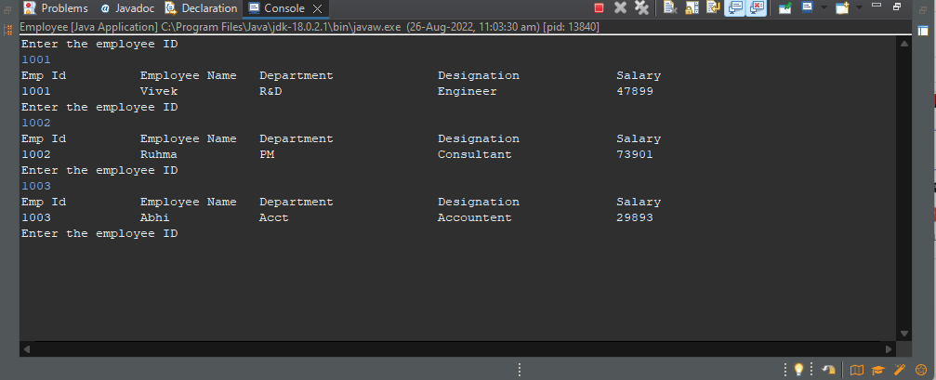

**Learning outcomes (What I have learnt):**

**1.** Learn How to create the array.

**2.** Array manipulation in java.

**Evaluation Grid (To be created as per the SOP and Assessment guidelines by the faculty):**

|  |  |  |  |
| --- | --- | --- | --- |
| Sr. No. | Parameters | Marks Obtained | Maximum Marks |
| 1. |  |  |  |
| 2. |  |  |  |
| 3. |  |  |  |
|  |  |  |  |